MINUTES

Local Station Board Meeting of October 16, 2016
Aris & Carolyn Anagnos Peace Center
3916 Sepulveda Blvd, Culver City, CA 90230
Local Station Board (LSB) Meeting
I. Call to Order 10:45 a.m.
Roll Call Taken, LSB Excused absence request: Mansoor Sabbagh has requested excused absence. Excused absence request approved by consensus. Unexcused absences: Aryana Gladney and Tejvir Grewall. Christian Beck, who has resigned as a LSB member, is also absent.

- Present are LSB members Chair Sharon Brown, Vice-Chair Roberta Eidman, and LSB Members Grace Aaron, Ken Aaron, Jonathan Alexander, Lydia Brazon, Sandy Childs, Leslie Fox, Stephen Frantz, Charles Fredricks, Jan Goodman, Steve Kaiser, Maggie LePique, Ali Lexa, Michael Novick, Reza Pour, Steve Pride, Dorothy Reik, Myla Reson, and Fernando Velazquez. Also present are Runner-up Richard Macias, Treasurer Fred Blair, Secretary Jaime Gomez, Parliamentarian Barbara Marbach, and GM Leslie Radford.
- Richard Macias seated in place of Christian Beck, who has resigned. Moved and passed without objection.
- Steve Kaiser and Barbara Marbach agree to be timekeepers.
- Agenda approved as amended by Myla Reson, by consensus. Amended to allow selection of December LSB meeting date earlier in the agenda.
- Myla Reson moves to schedule December LSB meeting for December 11, 2016. Motion passes without objection.
- Motion to have next meeting on 11/13/2016, accompanied by a Town Hall. Grace Aaron requests that motion be divided between date and town hall addition.
Town Hall motion carries 8 to 7, with two abstentions. Motion to have LSB meeting with Town Hall format on 11/13/2016 passes by 11 to 4, with 3 abstentions. LSB designates Michael Novick, Fernando Velazquez, and Reza Pour to organize Town Hall. These designees will decide upon venue and starting time. A motion to request that the LSB meeting with Town Hall format be aired by KPFK is approved without objection.
- Minutes of 09/18/2016 are approved by consensus.
- Time certain to adjourn of 1:30 agreed upon by 12 to 2, with 3 abstentions.
II. General Manager’s Report (Appendix I)
GM Radford responds to Q&A: Leslie Radford indicates that regarding two employees whose hours were cut, restoration of hours had been offered, but that one employee did not want hours restored. Ms. Radford would not elaborate, citing confidentiality concerns.

Jan Goodman Request: That programmer Roy Tuckman’s desires related to restoral of hours be included in the minutes, as comments by GM are misleading. The following communication from Jan Goodman and Mr. Tuckman has been authorized to be made public.
In following up on the discussion with the GM with regard to the budget, and the possibility of expanding the hours of Roy Tuckman in an effort to enhance revenue, Jan Goodman inquired of Roy Tuckman whether he was willing to go back to his midnight to 6 am hours.

His answer was "Of course! I always would have been so willing. My heart is with the listeners. I have never rejected that idea."

(also refer to Section VIII(d), and Appendix G)

III. Public Comments #1--12:05
IV. Announcements
V. PNB Directors and Treasurer Reports:
Jonathan Alexander: Working on getting audits done in national audit committee to regain CPB funding.
Michael Novick: WBAI and WFPW have grave financial problems. Finance chair resigned, and I have been elected to replace him as chair on the PNB Finance Committee. The Chief Financial Officer has also resigned, as discussed last month.
Grace Aaron: Serious discussion by national of leasing our New York station, WBAI. Generally the leases are 5 years, with a mandatory 5 year extension. In my opinion this would mean that WBAI would no longer exist. Hopefully our new national board will be able to devise a better plan to hold our network together. It is unconscionable that senior managers have not requested mandatory plans for austerity and fundraising measures from station (IED Plan, Appendix H).
Jan Goodman: Good news is that we have completed all of our station elections on time for the first time in a long time. Preliminary results may be found at Pacifica’s national website. Also, significant report from affiliates committee is that there is a nomination process going at this time. Last day for nominations for Pacifica affiliate directors is November 15, 2016.
Fred Blair: Fundraising projections for current fund drive was 15 days at $25,000 a day Projected fulfillment rate was 91%. The consequences of using these overly hopeful projections is an extension of fund drive days. We are looking at over 150 fund drive days, which is overly burdensome on staff members. We are basically in a liquidity crisis. Cash coming in is less than our bills, so critical decisions of who gets paid comes into play.
Q&A from LSB: There is discussion of Pacifica master tapes being sold on e-bay because of non-payment by PNB/PRA for a storage locker (Appendix H).
Jan Goodman makes motion to support Amy Goodman in her arrest over protest of Dakotah Pipeline Construction by Native American tribes. Motion passes by consensus (Appendix B).
VI. Public Comments-1:10
VII. Old Business
Resolution of Support for Sam Agarwal, CFO. Motion passes 12 to 4, with two abstentions (Appendix C).

VIII. New Business
- Motion: Policy Change to Allow Treasurer to Chair Finance Committee, passes by consensus (Appendix D).
- Motion: Set-up E-mail Communication Line for Listeners, passes by consenus, as amended by Michael Novick.
Amendments are that 1.) “bilingual English/Spanish” be placed between the words short and ad, in the clause beginning with the word “Further”, and 2.) that a clause be added stating: “Finally, a written report will be made monthly fdrom the committee to the LSB regarding the input received and dialogue engaged in.” (Appendix E).
- Motion: Conduct Lapsed Donor Survey, passes 13 to 1, with one abstention. (Appendix F).
- Motion from the floor by Grace Aaron: Budget Motion, passes 8 to 4, with two abstentions (Appendix G).

IX. Closing Business
Meeting adjourns at 2:12 p.m.
Appendix A - Required Notices
Proper notice of this meeting was posted on the KPFK Calendar and at the Pacifica Calendar as required.
Appendix B –Motion to Support Amy Goodman/Dakotah Pipeline Arrest
Resolved: That the Pacifica National Board be advised to go on record as supporting Amy Goodman in her rights to report the news, and that North Dakota should stop embarrassing itself and should immediately drop all charges against Amy Goodman for doing her job as a journalist, covering a violent attack on Native American protesters.

Appendix C – Resolution of Support for Sam Agawaral, CFO
Whereas, Pacifica’s CFO Sam Agarwal submitted his resignation to the Pacifica National Board (PNB) on September 8, 2016. Agarwal came to Pacifica in January 2016, at a time when the Foundation was already in extreme financial and organization distress. He brought depth of experience in non-profit financial management as well as an MBA.
Whereas, Mandatory financial Audits had not been completed for years, forcing the loss of critical funding from the Corporation of Public Broadcasting. General Ledgers across the network were not up-to-date or maintained in a timely, professional manner.
Whereas, The PNB and General Managers at Pacifica stations have not provided Agarwal with urgently-requested turnaround plans, solid budgets and spending restraints. In addition, the PNB often obstructed or limited meeting time to discuss vital reports from Agarwal or the outside Audit firm.
Whereas, KPFK has not had a full-time Business Manager for over a year. This position ideally is the professional who works with the GM and CFO to monitor cash flow, develop operating budgets and business recovery plans. Other stations lack key personnel as well.
Whereas, Despite these impediments, Agarwal consistently performed with integrity and professionalism. He demonstrated openness and equity dealing with all stations, responded to inquiries from LSB and Finance Committee members and always rose above the fray while forcefully working for solutions.
Therefore, Be it resolved, that the Local Station Board (LSB) of KPFK extends its appreciation and respect to Sam Agarwal. The Board recognizes the time, effort and expertise he dedicated to the affairs of Pacifica Foundation.
Further, LSB would support a role for Sam Agarwal as consultant to Pacifica should conditions force a business transformation
And lastly, the LSB instructs that this Resolution be entered into official minutes and a copy be forwarded by Board Secretary to Mr. Agarwal.
Appendix D – Policy Change to Allow Treasurer to Chair Finance Committee
This motion asks that the Local Station Board approve an exception to the committee policy that specifies that Chairs of committees must be LSB members.
This exception is required to allow the Treasurer, who is a Board Officer but need not be an LSB member, to serve as Chair of the Finance Committee. This assumes the Treasurer wishes to hold that role, and he/she is elected by members of the Finance Committee.
Within the Finance Committee, we ask that Treasurer’s status be the equivalent of an LSB member for the purpose of LSB/public committee composition.
Appendix E – Set-up E-mail Communication Line for Listeners
That the Strategic Planning Committee conduct a pilot project to engage listeners. This will be with volunteer(s) supervised by this committee who will conduct 2 way email communication with listeners of KPFK.
The Strategic Planning Committee requests that the KPFK GM entrust the password to access the Inbox of go@kpfk.org so that emails to that address be responded to. It is understood that all responses will include the following disclaimer:
This email is written by a volunteer under the guidance of the KPFK Local Station Board and does not necessarily reflect the opinions or policies of KPFK or the Pacifica Foundation.

Further, the Strategic Planning Committee requests that a short bilingual English/Spanish ad be placed on the KPFK website inviting people to send emails to this email address and that occasional on-air announcements be made giving the email address and its purpose.
Finally, a written report will be made monthly fdrom the committee to the LSB regarding the input received and dialogue engaged in.
MOTIVATION:
This type of market research may be useful in gauging listener interests and may help to build community support for the station.

Appendix F – Conduct Lapsed Donor Survey
The Strategic Planning Committee empowers Steve Kaiser and any volunteers he can recruit to conduct a survey of lapsed members in coordination with the Membership Director and in communication with the Community Advisory Board so that this survey does not overlap with what the CAB is doing.
It should be noted that KPFK membership lists must never leave the station or be given out to volunteers except at the station as needed for the survey.
Appendix G – Budget Motion
Resolved: That in the 2017 budget an income improvement item of approximately $134,000 be inserted and that this income will result from the restoration of Roy Tuckman's and Sonali Kolhatkar's hours on the grid.

Appendix H – Miscellaneous Documents from National, etc.
PRA Atchives Found on Ebay
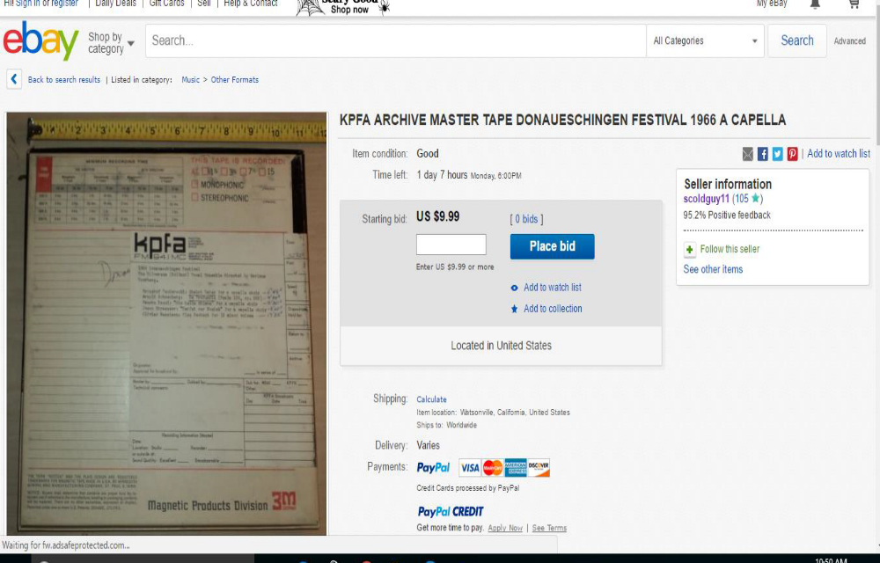

CFO Sam Argarwal Resignation Letter to PNB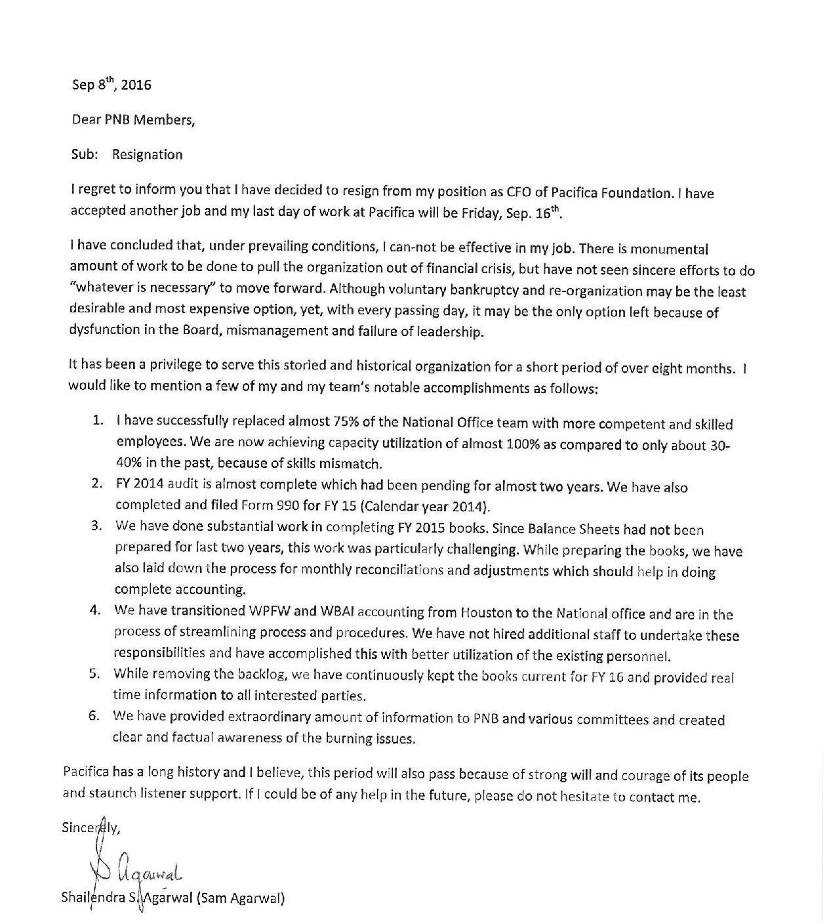
IED Lydia Brazon Recovery Plan for Pacifica
Recovery Plan for September 15, 2016 PNB Meeting by the IED, Lydia Brazon
The current financial situation is unprecedented in the many years since I've been in Pacifica.
Contributing factors include a combination of inherited, unsustainable, massive debt, dwindling membership and listeners, and last but certainly not least, the absence of CPB funding that basically brings us to this grave financial state.
In order to properly effectuate this plan, the PNB needs to approve it in whole or in part. Some, is simply reporting on something previously discussed and ongoing and I don’t believe requires a PNB vote, such as the appeal letter. However, I am numbering seven recommendations so that the plan can either be passed in its entirety as a consent calendar, or numerically divided to be voted on individually. Some measures need to be enacted simultaneously and others sequentially. Either way, it needs to be approved by the PNB to be considered by the auditor. Those items which constitute an expense, would be contingent on our affordability at the time.
Many of the expense reducing measures have already taken place and were necessary regardless of our current state, but others will cost us in the ability to grow our membership and listeners. Some measures are relative to what can be done depending on the confines of our union contracts at four of our stations. A recovery plan must both reduce our expenses and grow our listeners to be effective.
Currently at the PNO, $100,000 per year savings are being realized from the absence of a salaried E.D. and a reduction of two, soon to be three, staff in PRA. Depending on how long it takes to replace our CFO who has resigned effective September 16, the reduction of a monthly salary based on $120,000 per year will be a factor in the short term. Additional reductions regarding the departure of other employees in this and other units will be addressed in executive session.
I have received a $2,000 loan offer from one director so far toward the mailing cost of the PNO appeal. And, although we have about 1/3 available on the credit card, we need to raise more for this mailing. The returns from the appeal letter to PBS and NPR subscribers will be reported to the PNB so as to gauge the effectiveness and adjust the next wave of appeals accordingly. For example, and this was suggested by Jan Goodman, to offer a thank you gift as we do for our on air drives and which may be a consideration for the subsequent mailing.
Union negotiations continue at three stations over accommodating our situation at KPFA, WPFW and KPFK including staff reductions.
1. Restoring our CPB grants eligibility needs to be the first order of business. Therefore, I think we first need to make sure that the business managers are current with their reconciliations and schedules for 2015. The prompt completion of 2015 will reduce the cost of the auditors which for 2013 and 2014 was significantly higher than expected. I recommend weekly updates from all business managers and where the PNO is functioning in that capacity for certain units, the same is expected of them. The updates should be in writing and chronicle their progress every single week.
2. Although the former E.D. and by extension, yours truly, were tasked with exploring mortgages, it's clear that in addition to the audit report, and financial statements, the value of Pacifica’s assets must be presented to make a credible case. The audit report reflects our assets, post-depreciation. To obtain either a mortgage or a credit line, a true market value picture of our assets must be presented. I have therefore contacted an appraiser who's a Pacifica supporter and who will appraise the KPFK property in October and he has also made referrals for a business appraiser for PRA and property appraisers in Berkeley and Houston for our real estate properties there as well. We can later obtain appraisals for our licenses. The point is, we must know the true value of our assets. Certainly NOT in order to sell them but rather to leverage them for credit lines, a mortgage or in the case of the PNO, to lease. In other words, in order to make an informed decision, we need to have this basic information. This information coupled with the audit report, and current financial statements are elements needed for consideration by financial institutions as well as applying for grants. For example, we intend to apply for grants for the renovation of the PNO plus adjacent, which are in dire need of repair and renovation for our employees in the PNO and to maximize the value of that property for lease or mortgage.
3. We are in need of a webmaster or webmaster service provider who can develop and maintain services for pacifica.org and also for other units in need of these services. Some of our sites are not user friendly and are not sufficiently interactive to be useful to listener growth and donations through the sites.
4. I’ve consulted John Crigler about the feasibility of an internet station to start with, in Chicago so as to introduce a new listener, member and revenue stream in a city with activism and vibrancy that wholly compliments our mission. My understanding is that because most of the licenses are based on audience and since we wouldn’t have much to begin with, the cost per license is only in the hundreds. We would initially fill the station’s airwaves with existing programming from our stations, until we introduce locally produced community programming.
5. In 2014, the PNB in essence tabled consideration of a Lease Management Agreement (LMA) or Public Service Operating Agreement (PSOA) for WBAI and so it’s the PNB who would need to take it off the table for reconsideration or for me to solicit updated proposals. The process, if the PNB were to choose to engage with any entity is a lengthy one. If the PNB even wants me to solicit more information or updated proposals or to even see if any of the 2014 applicants are currently interested, I just need a motion to allow that. This does not need to be a motion to approve a given proposal or even to enter into a LMA at this juncture.
6. The station and unit managers are in the process of producing their cash flow plans but I believe the more credible projections are for three months. Without the expectation of guaranteed funds from CPB for example, they can basically only factor in their expected reductions and fund drive numbers based on recent past performances, some major donor and some events. Beyond that, it gets very speculative. What I’ve asked for are specifics per pay period for payroll and health care and central services. I believe these specific plans should be provided quarterly.
7. Regarding a related bylaws amendment recommendation, I think it would be most beneficial for membership to be afforded to all who donate $25 or more to any of our units not just the stations units. It would serve as a beneficial incentive to enable all of our units to offer membership.

CFO Agarwal’s Comments on Recovery Plan
CFO’s comments on Recovery plan provided by IED for Sep 15, 2016 meeting
In general, majority of action items should be part of a recovery plan. However, waiting for a long time has only made problems worse. Most of the proposed actions will have their intended effect in 6-12 months and will be far short of the extent of turnaround needed.
Even after considering the savings of ED and CFO salaries, National Office is suffering with an immediate cash shortfall of over $200,000. Recovery plan does not cover any ideas for resolving short-term needs which are critical and can-not be ignored. Both National office and PRA can-not sustain their operations without payment of Central Services which is not being paid by the Stations.
Similarly, there are serious cash flow shortages at the stations which need to be bridged soon. It is urgent that action be taken to address this immediate need. I do not think that there is any need to charge the credit card for mailing expenses for the fund drive. Enough effort has not been made to generate no-interest loans. This should be sufficient to meet this cost, if approached properly.
Most importantly, the plan does not assign responsibility who would perform the assigned tasks or provide any deadlines when those tasks will be completed.
With respect to specific items, my views are as follows:
1. While restoring CPB funding should be a top priority, however, we should be realistic in our expectations. We have so far not been able to complete FY 14 audit for last several months.
a. Capacity of the National Office has been degraded that it can-not hire and retain skilled staff to complete FY 15 books and prepare schedules to provide them to the auditors. Audit itself is going to take considerable time to complete
b. National Office does not have the staff to monitor the progress, remove deficiencies and continue to make headways.
c. There are no full-time Business Managers at WBAI and WPFW. KPFK has not hired a Business Manager although approval was given in Jan. 2016. Business Managers need constant supervision and guidance to complete this task. Reporting on a weekly basis will not help if there is no one in the National Office to evaluate their work.
d. By the time the FY 15 audit is completed (approx. March 2017), FY 16 audit will be due. It is highly likely that CPB papers can-not be filed until we have the most current audit which will be way past into late 2017. CPB funding will all be lost by then for FY 16.
2. While appraisal is required to know the real value of the assets, it is of limited use in day to day operations. All external parties like Bankers, Insurance Company and Auditors want to see improvement in cash flow. As per accounting standards, these assets can-not be stated at their market value in the financial statements. As these can-not be sold, they do not improve the cash situation

3. No comment

4. We should look into the cost benefit analysis of an internet radio. I believe that incremental revenue from such operations would be very minimal and may not justify the efforts.
5. I support LMA for stations where no other option seems feasible. However, we need to look into the terms and conditions very carefully. As they do not assume old liabilities, we must consider how they have to be paid off

6. Even if the Unit Managers provide projections for 3 months, there would be some road map to go with and hold them accountable. PNB needs to assign clear responsibility and deadlines to have this task completed. Considerable work is needed to bring any credibility in this process.

7. No comment
To recap, the recovery plan will not bring any short term relief which is urgently needed. As Grant Lam (the auditor), is not aware of our cash flow problem, he is not concerned how we manage our day to day business. In my view, a Comprehensive Recovery Plan must contain the following additional elements:
a. Immediate plan for payment of essential services like payroll, audit fees, insurance etc. at the National Office
b. Plan for payment of Election expenses
c. Formula for payment of Central Services on an ongoing basis
d. Ensuring adequate staffing at the National Office
e. Funding for upgrade of Great Plains and security software
f. Negotiation and reduction of debt with Empire State building
g. Negotiation and reduction of Democracy Now accrued liabilities and commitments going forward
h. Programming changes at Stations to attract more listeners
i. Sharing best practices across stations to make fund drives more effective
j. Streamlining fund drives to increase fulfillment rate
k. Special campaign to appeal to major donors
l. Standard form of reporting by all Stations at regular intervals
m. Restructuring of PRA operations to reduce dependency on Central Services
n. Establishing a process to expedite decision making at the Board level, particularly on financial matters

CFO Sam Agarwal’s Final Report to PNB – Sep. 15, 2016
Concluding and Final Report
1. National Office matters
a. National office conditions continue to deteriorate at a fast pace. There is no money to pay for essential services. All attention is focused to get enough money to make its Sep. 30th payroll and health care payments.
b. A list is attached which shows the payments that need to be made for the next 30-45 days with a total of approximately $250,000. A copy of the bank statements as of 9/13/16 is attached which shows a balance of $1,807.57. This demonstrates an extremely challenging situation at the National Office
c. A list of outstanding Central Services is attached. This by itself is the root cause of the problem. National Office can-not function if the essential blood supply is cut-off.
d. There is acute staffing shortage at the National Office. Since a Senior Accountant (Consultant) has left about two weeks back, his replacement has not been made. As there is no money, it would be irresponsible to hire someone. To put it in perspective, there are 3 persons in the accounting team (besides CFO) whereas there used to be 5 in 2015. Since then, WPFW and WBAI accounting has also been transitioned to the National office but no additional staffing has been made.
e. Under the circumstances, it would be futile to expect that FY 2015 books and audit will be completed any time soon. There is substantial time and effort needed to accomplish this task. Books are not in a shape where the audit can even start anytime soon.
2. List of Outstanding Items
a. A list of outstanding items is attached to help my successor take care of the priorities, going forward
3. FY 14 Audit is held up in need of a recovery plan, amongst other items. As IED is pursuing these matters, a full detail is not provided here

4. There has been no improvement in Station’s finances as was last reported. Recovery plan must include resolving short term cash flow needs
THANK YOU VERY MUCH for giving me this opportunity. Whereas I may have contributed to bringing an awareness of financial matters and getting somethings done, I also learnt a lot. Most importantly, it was an unusual experience to conduct Board meetings on the phone. It requires preparation of a very different kind. I cherish this experience as it would help me in many different ways.
Thanks again.

Appendix I – General Manager’s Report
Report to the Local Station Board 16 October 2016
PERSONNEL
Roz Larman, host of “Folkscene” for more than forty years with her husband Howard until his passing in 2007, herself passed away last weekend. As the L.A. Times noted, “the Larmans became an institution in the local folk underground as they helped expose music and artists usually ignored by commercial radio.” A tribute show is planned.

By the time of the meeting (but not as of this writing), the Business Manager and Chief Engineer positions will have closed. On Monday, I will send selected resumes to Raul Salvador, foundation financial consultant, and Jon Almeleh, national technical director, for review.
We have hired Donna Walker as a half-time subscriptions assistant, partially filling the full-time position vacated by Janee Taylor.

FUND DRIVE
The fund drive has slowed down from a strong start. As of Thursday at 5PM, as I write this, we are at $210,000, or $21,000/day after subtracting the listener donations to Haitian hurricane relief. If we continue at this rate, we will need to extend the drive 4-5 days to reach the $550,000 goal. We have also agreed to add one day for the Pacifica Radio Archives so they can reduce their traditional November 2-day drive by a day.

I would like to applaud our listeners, who’ve donated over $20,000 to aid Haiti. I am coordinating with Margaret Prescod to identify a qualified grassroots non-profit to accept the funds.
BUDGET AND FINANCES

I’m attaching the latest revision of the budget. The major changes are including the August income statement (attached), the September 30 bank balance, and a tab called “Prioritize CS.”
“Prioritize CS” is a demonstration of what it will take to make our full Central Services fees, along with our payroll, health care, arbitration settlement, and a portion of the outstanding premiums. Please note the descriptions of reductions necessary to accomplish this in the far right column, including eliminating office phones, reducing broadcast hours, and giving up translators, repeaters, and two of our websites. It’s also predicated on making the same income without these resources, which is highly unlikely. If the “Prioritize CS” budget is approved, we’ll still be, at best, $57,000 short of the money we’ll need to pay off our premium and other debts. I hope the LSB and KPFK’s PNB members will actively oppose any such budget.

I met with the national finance committee on September 20, and I will be meeting with them again on either October 18 or 25. They have passed a motion to anticipate the same or greater National Office fees in FY17. We also received a recommendation to increase income, and I would appreciate the LSB’s
Assistance in formulating and committing to concrete plans to do that in time for the Tuesday meeting. We will need $12-19K each month to fully fund the National Office at our current obligation under the “Annual Budget” tab. I will notify the LSB of the actual end date for the current drive as soon as it’s determined so you can organize your calls from Studio A to lapsed donors.
We have spent about $9,100 so far this month on premiums, with $4,100 budgeted for the rest of the month, not including the hurricane relief monies. We will deliver the bulk of those monies next week.
We will have completed the requirements for the 2015 audit as soon as the National Office can research a few remaining items.

The operating bank account balance is $119,956.32 as of October 13. The most recent income report is attached.

ELECTIONS
The elections were extended through noon on October 10. Between October 1 and 10 we played candidate carts in Spanish and aired a bilingual Spanish-English candidate forum. We have agreed to advance $15,000 to pay TruBallot against our October Central Service fees. The elections were declared closed with quorum on October 11.

OPERATIONS
There have been problems with the air conditioning in Studio A, and we have called our air conditioning service company for repairs. It should be noted that our AC company has advised us that several of our AC units have outlived their rated service life.
An LSB member secured two computers for the station. Thanks for Doug for changing light bulbs.

PROGRAMMING
The Program Director has no report.
OUTREACH, FUNDRAISING, DEVELOPMENT
Greg Palast agreed to ten additional screenings of “The Best Democracy Money Can Buy” to benefit KPFK. It was a stellar outreach event, and we anticipate significant funds for the station. Staff and management made appearances.

We tabled at the Anarchist Book Fair.

The Association of Spanish-language Programmers held an event on October 8 in the parking lot and raised about $600.

The Membership Director says, “Live long and prosper.” KPFK Rpt to the LSB 4/16/2016 p. 3
Respectfully submitted,
Leslie Radford General Manager, KPFK 14 October 2016 p. 4

Addendum: Responses to September Motions, Appendices B and C

1) The advertising costs for the business manager and chief engineer positions were accrued in September and so should not impact the FY17 budget.

2) The fund drive tab from last year is correct in amounts. It was incorrect by about 3 days, which makes no difference to total income. The difference between the finance committee chair’s calculations, those based on the posted reports, and this are that the posted reports include 7 days in May that only programming originating at KPFA included pitches and 3 days in July when the phone room was closed for the holiday weekend.

3) The pension monies are included in a line item in the budgets.

4) The plan for improved programming has not begun since the evaluation of current programming is not complete.

5) Paying past premiums is included in the budget you have and the one attached, in the tab “Accounts Payable” and carried onto the cash flow tab.

